The ACE Partnership

ACE is a partnership between schools and families that allows students to:
ATTEND – by being present for remote or on-campus learning with a feeling of wellness, safety, and belonging
COMMIT – by showing dedication to learning with a feeling of connection to what is being taught
ENGAGE – by displaying academic progress with a feeling of confidence and accomplishment
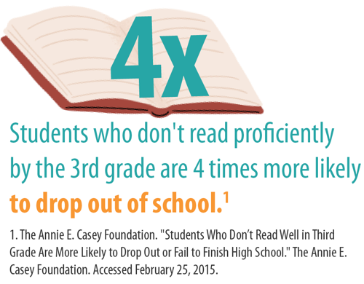
Good Attendance Is a Result of a Strong
School-Family Partnership
As schools, we commit to…
- Implementing practices that allow students to attend school remotely or on campus with a feeling of wellness, safety, and belonging
- Designing and delivering curriculum and instruction that allow students to feel connected to what is being taught
- Promoting growth mindsets that academic achievement and success is achievable by all students
As schools, we can ask families about…
- What children need to feel well, safe, and belonging
- How to incorporate their cultural identities into the classroom
- What they need from adults to feel successful

As families, we commit to…
- Prioritizing the need for our children to attend school every day
- Encouraging our children to commit to their work, not give up, and ask for help when needed
- Communicating with our child’s school to help them find success in each subject
As families, we can ask schools about…
- What the attendance policies are for remote and on-campus learning
- How we can best support our children as they learn
- How our children are performing so we know their progress
How Does Attendance Impact Student Success?
- Data shows that chronic absence directly affects student achievement
- Regularly missing school as early as pre-K and kindergarten can lead to lower academic performance across all ages, specifically affecting reading development by the end of 3rd grade
- Chronic absenteeism carried into the middle and high school years is more likely to result in school dropout or delays in graduation
- Early warning systems indicate that chronically absent 9th graders are 10 times more likely to not graduate on time

Visit ace.e3alliance.org/family for more resources.

