Attendance Staff:
Tips on Family Outreach

ACE is a partnership between schools and families that allows students to:
ATTEND – by being present for remote or on-campus learning with a feeling of wellness, safety, and belonging
COMMIT – by showing dedication to learning with a feeling of connection to what is being taught
ENGAGE – by displaying academic progress with a feeling of confidence and accomplishment

CONTACTING FAMILIES ABOUT ABSENT STUDENTS
We know that schools are responsible for contacting families of absent students, and in particular, chronically absent students. As a result of the pandemic, this responsibility may be greater than usual. Below are some tips inspired and adapted from teachers, advocates, and school officials from around the country to help staff amplify efforts while also building relationships with families. Remember, this is a school-family partnership to help all students ACE their school year!

Start with the basics
- Ask students for their home phone number, as well as any relevant cell phone numbers.
- Use all available apps - texts, emails, learning management systems, ClassDojo, etc.
- Exhaust all resources to get good contact information for each student.
- Reach out to siblings, emergency contacts, or classroom buddies via teachers.
- Look at school forms; accurate phone numbers are often on free and reduced lunch forms.

Seek out the families
- For younger children, use drop-off or pick-up as an opportunity to reach parents or relatives and ask them to complete forms with contact information.
- Send a formal letter home informing parents of their legal obligation to provide up-to-date emergency numbers and contact information.
- Address possible language barriers by providing Spanish speakers (or other home language).
- Conduct the home visit to ensure all contact information is current and accurate.
- Let the families know your goal is to maintain a relationship with them so you can work together as partners to improve their child’s attendance, and increase their chance of school success.

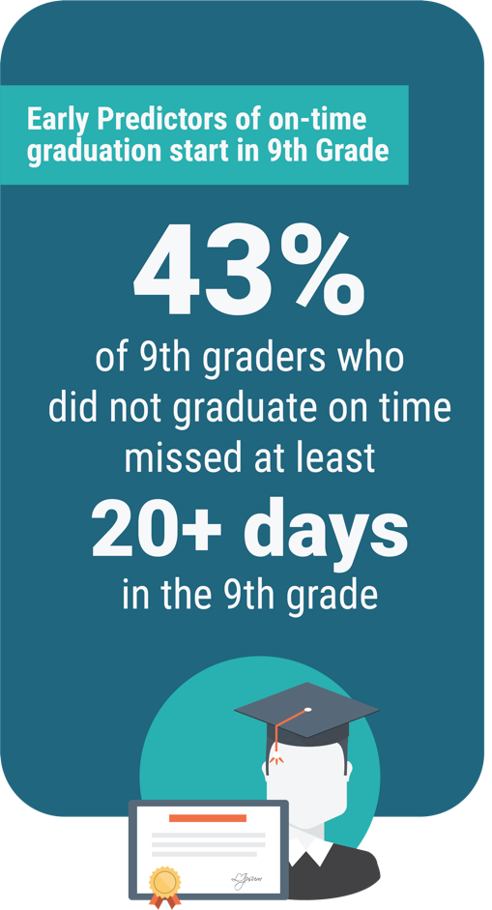

For all ACE resources, visit ace.e3alliance.org.

Get creative
- Identify a constant contact in the school, a person that families can rely on and identify with, and allow that relationship to grow. Provide an alternative contact person, as needed.
- Alert office workers of upcoming events that parents are likely to call about, such as school picture day. This is a good time to ask parents for contact information. Use address information to locate families who live near chronically absent kids. Another way to reach hard-to-find parents.
- Teach basic Spanish phrases, as appropriate, for school contacts to use that will help families feel more supported and willing to respond.
- Leverage existing community resources to establish outreach workers who can make personal contact with families through calls and home visits.
- Call for a wellness check, if all else fails.

