Talking Points:
How to
Communicate
with Families
and Students

ACE is a partnership between schools and families that allows students to:
ATTEND – by being present for remote or on-campus learning with a feeling of wellness, safety, and belonging
COMMIT – by showing dedication to learning with a feeling of connection to what is being taught
ENGAGE – by displaying academic progress with a feeling of confidence and accomplishment

WHAT IS YOUR MESSAGE?
Schools and families that form a partnership around attendance successfully establish practices that keep students in school, whether in remote or on-campus learning. Using the ACE campaign, Central Texas school districts can promote a feeling of wellness, safety, and belonging while connecting students to the learning and boosting self-confidence. A robust partnership that prioritizes attendance should align with the following:
- Attendance matters for success in school and life beginning in pre-K and kindergarten.
- Poor attendance is not just about unexcused absences or children willfully skipping school – excused absences can affect performance, too. And they add up quickly.
- As adults who are active in the lives of children, we are collectively responsible for making sure they develop the habit of regular attendance.
- The greatest disadvantage related to chronic absences is loss of instruction. Even a few minutes makes a difference. Students should avoid leaving class early or arriving late, and remain engaged and committed.
- If challenges arise at home related to internet connectivity, health care, housing, transportation, or food, families should feel confident in seeking help from the school community.
- When challenges arise that may impact students’ ability to fully attend, commit, and engage, schools communicate with families as appropriate.

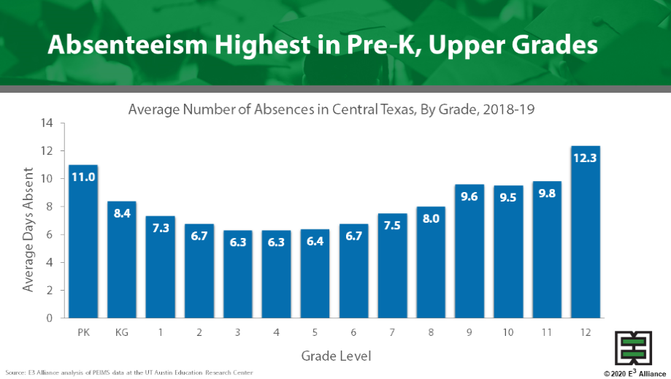

Tips on talking to families . . .
- Good attendance will help your children do well in high school, college, and at work.
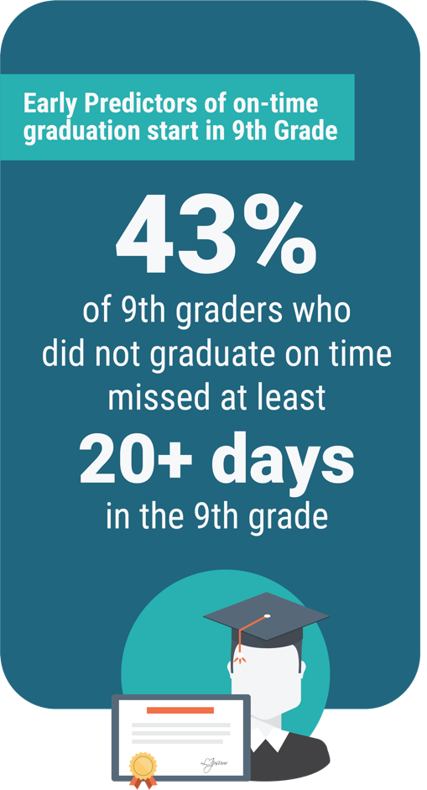
- There are many reasons beyond academics for your child to participate in school like opportunities to try sports, musical groups, theatre, academic clubs. Students often discover their passions while in school.
On their own, these extracurricular activities are expensive and more difficult to experience beyond the high school years. Encourage your child to attend, commit, engage, and find their joy.
- Whether absences are excused or unexcused, they all represent lost time in the classroom and a lost opportunity to learn.
- If your children miss 18 days, just one day every two weeks, this will negatively impact their ability to graduate on time.
- Attendance matters as early as pre-K and kindergarten. Children who miss too many days in the early years may have trouble with reading by the end of third grade.
- Too many absent students can affect the entire class, slowing down instruction as your child’s teacher tries to help each student keep up with the work.
- If learning remotely, provide a comfortable workspace at home, and hold your children accountable as if they were learning on campus.
- Your school leaders and staff are ready to help. You are not alone. We understand the challenges. We are in partnership with you. Communicate with us so we can help serve you better.

Tips on talking to students . . .
Elementary Students
- School helps you learn important skills like getting along with others and how to ask for help when you don’t understand something.
- You are learning much more than reading and math. You are learning how to explore the world around you.
- With good attendance, you don’t miss out and can spend more time learning with your friends.
- School can get hard if you miss too many days. Sometimes it’s tempting to miss because you don’t feel well. Skipping even one day can get you behind.
- Your teachers want you to have fun and be successful. Try to let them know if something is bothering you or keeping you from staying focused. Talk to your family and they can talk to your teacher.

Secondary Students
- School helps you learn important skills like showing up, being on time, finishing what you started. It prepares you to be successful in the world.
- You are learning much more than math and science. You’re learning how to think creatively and critically so you can get a job and earn a living later in life. Know your goals and align your behavior with those goals.
- School gives you opportunities to try many different sports, musical groups, theatre, academic clubs. These experiences often help you discover your passion and what you excel in. After you graduate, it’s hard to find these same opportunities again. Take advantage of what there is for you now, right here on campus.
- With good attendance, you have a better chance of graduating on time with your friends, and doing well in college and in your career.
- School only gets harder when you miss too many days. Sometimes it’s tempting to miss class because you’ve got too much work or you’re unsure about classwork. Skipping a day only makes that worse.
- Each one of your teachers wants you to be successful. They only know what you share, so communicate with them if you’re facing challenges that make it difficult to attend, commit, or engage.

Tips for front office what to say . . .
With families
- We are so glad to see (child’s name) back at school. We miss them when they are not here!
- Thank you for providing the medical note for the absence. Can I check for you on how (child’s name) is doing with their attendance this year?
- How can I help your child feel better after having missed (# of days) days of school?

With students
- We miss you when you’re not at school!
- Have you checked, or has your family checked, with your teachers to see what you missed?
- What can I do to help you feel better after missing (# of days) of school?

For all ACE resources, visit ace.e3alliance.org.

