Help Your
Elementary Student
ACE Their
School Year

ACE is a partnership between schools and families that allows students to:
ATTEND – by being present for remote or on-campus learning with a feeling of wellness, safety, and belonging
COMMIT – by showing dedication to learning with a feeling of connection to what is being taught
ENGAGE – by displaying academic progress with a feeling of confidence and accomplishment

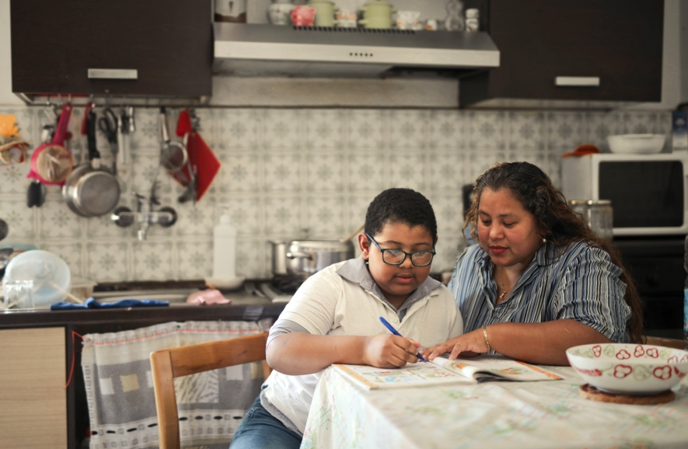

KEEP YOUR CHILD ON TRACK

Attending school, committing to school, and engaging with school can result in your child’s academic success from pre-K all the way through high school. As children grow and develop from young to more independent learners, families are the key to their success. Partnering with us, your school, around attendance will ensure your child will ACE their school year!

WHAT CAN YOU DO?
Support your child’s academic success
- Talk about the importance of paying attention in school every day and give them tips (like sitting at the front of the classroom, making sure their remote learning space is comfortable and maximizes productivity).
- Model how much you prioritize attendance in your own life and talk regularly with your child about what they need to feel and stay successful, whether learning remotely or on-campus. Stay in contact with their teacher.
- Help your child maintain daily routines like finishing assignments and getting along well with other students. Be consistent with morning and bedtime routines.
- Keep your child healthy by scheduling flu vaccines and other required shots; however, try not to schedule dental and medical appointments during designated school hours.
- Don’t let your child stay home or disengage from school unless truly sick. Complaints of headaches or stomachaches may be signs of anxiety. Missing just a day or two every few weeks can make your child fall behind severely in school.

Help your young learner stay engaged
- Find out if your child feels engaged in their classes and feels safe from bullies, cyberbullies, and other threats. Make sure to address any behavioral issues. Partner with their teachers and school on solutions.
- Seek help from teachers or tutors if your child is struggling. Make sure all teachers know how to contact you.
- Be aware of your child’s social interactions. Peer pressure can lead to inappropriate behaviors, while students without many friends can feel isolated.
- Encourage meaningful activities outside of school.
- If learning remotely, help your child understand that similar rules apply as with on-campus learning.

Communicate your needs
- Be familiar with the school’s attendance policy – incentives and penalties. Know what attendance procedures are in place for remote learning.
- Talk to teachers if you notice sudden changes in behavior. These could be tied to something going on at school. Reach out to their counselor, if needed.
- Check your child’s attendance and grading records regularly to be sure absences are not piling up and school work is being done.
- Ask for help from school officials, afterschool programs, or community agencies if you’re having trouble getting your child to school. Reach out to other parents for ideas.
- Let school officials and leaders know what you and your child need to attend, commit, and engage whether learning remotely or on campus.

Visit ace.e3alliance.org/family for more resources.

